|  |  |
| --- | --- |
|  |  |

**eProject Document**

XYZ Pharmaceuticals

|  |  |
| --- | --- |
| **Group 6** | |
| **Members** | Phạm Đình Bách – B8948  Đỗ Văn Minh – B8924 |
| **Instructor** | Lai Duc Chung |
| **Batch** | C2009G2 |
| **Semester** | III |

**🙠 Date of issue 31-10-2022 🙢**

**🙠 End date 30-11-2022 🙢**

**Table of Content**

1. **Problem definition**
   1. ***Introduction***
   2. ***Existing Scenario***
   3. ***Proposed scenario***
2. **Customer Requirement Specification**
   1. ***Customer Requirement***
   2. ***Hardware – Software Requirements***
3. **Architecture and Design of the System**
4. **Flow Chart**
5. **Data Flow Diagram**
6. **Entity Relationship Diagram**
   1. ***Entity relationship diagram***
   2. ***Entity - Attributes***
7. **Database Design/Structure**
   1. ***Database relationship diagram***
   2. ***Table design***
8. **Some typical interface**
9. **Task Sheet**
10. **Check List of Validation**
11. **Submission Checklist**
12. **Problem Definition**
    1. **Introduction**

* The pharmaceuticals sector is a highly R&D intensive industry. The XYZ is an Pharmaceuticals company which deals with products like Capsule/Encapsulation, Tablet, Liquid Filling, Blending, Process Equipment, Used Equipment. This organization now wants the entire process to be explained in as a web application so as to enhance the advertisement of the company and to increase its profit. For this the company has approached to make the website and also provided the list of the functionalities expected.
  1. **Existing Scenario**
* The Company has approached you to make the website and also provided the list of all the links and functionalities provided. They also want to provide a link of making a career where the interested candidates can login and provide their information (like their personal and education, professional details and also they will have the link to upload their resume).
* There would be link for User Quote where user can provide their valuable feedback or any requirement.
* It also wants to explain the list of the process being carried along with the details and dimension. The Process like Capsule/Encapsulation, Tablet and Liquid Filling must be explained.

* 1. **Proposed Scenario**
* Home Page: It should have the introduction description about the company. All the links must be stated in this page. The link like Home, About us, Products, Contact us, Careers, Quote, Admin Login.
* About us: it should flash the details of the Company (organization)
* Products: Here the list of the Products which are developed must be stated. Products like:
  + **Capsule/ Encapsulation**: The details of the products must be entered like:
* Output
* Capsule size ( in mm)
* Machine dimension
* shipping weight ( in kg)
* Examples of the list of the products are mentioned below:
* Profill 100 (2000 c/hr): it produces 2000 capsule per hour.
* Profill 3007 (9000 c/hr): it produces 9000 capsules per hour.
* Model 8S (18000 c/hr): it produces 18000 capsules per hour. Note you can take any other products also.
* **Tablet:** Here the details of the Tablet process must be there. It will store the details like
* Model number
* Dies ( like 1 set, 2 set and so on)
* Max Pressure
* Max Diameter of tablet (in mm)
* Max depth of fill (in mm)
* Production capacity
* Machine size
* Net Weight (in kg)
* Examples of the tablet are mentioned below
* TDP
* VSP
* CP 501 (Note you can take any other product also)
* **Liquid Filling:** Here the details of the Liquid filling must be explained. It will store the details like :
* Air pressure
* Air Volume
* Filling Speed ( Bottles/min)
* Filling Range ( in ml)
* Examples of the Liquid filling is DHF( Double Headed Filter)
* Contact Us**:** Here the contact details must be flashed.
* Quote us: Here the suggestion or effective feedback can be provided. The details like :
* Full Name
* Company Name
* Address
* City
* State
* Postal Code
* Country
* Email Address
* Phone
* Comments
* Career: It will provide the candidate opportunity to apply for the job by creating their account. There will be two section one for Candidate Login and other creating the account.
* Candidate Login : It will open the particular candidate account by using authentication( with their existing email Id and password they select). Once the account is opened the candidate will get three tabs to be modify:
* Resume (for uploading the resume)
* Personal details
* Education details
* Creating Account: Here the candidate account will be created by filling all the above mentioned details along with the password (authentication purpose).
* Admin login: it will have to main task
  + The details of the site can be updated. Admin can also view the details of the job seeker candidate.
  + If the candidate profile is found to be interest then their will be option of Email in the same page. Once the admin click on the email option then a composing mail window must be opened with option like TO, Subject, Text and Send button. In the text the admin will call the selected candidate for the interview.

1. **Customer Requirement Specification**
   1. **Customer Requirement**
      1. **Users of the system**

* Admin
  + 1. **System functions**

|  |  |
| --- | --- |
| **User** | **Functions** |
| **All Users** | * Login * Change Profile |
| **Admin** | * Candidate management * Category management * Manufacturer management * Product management * Product attribute management * Manager (Admin) management * Feedback Management |

* 1. **Common functions**

|  |  |
| --- | --- |
| **Login** | |
| Input | Login to system, user must be enter username and password |
| Process | Access information in database |
| Output | Result of login |
| **Change Profile** | |
| Input | Information details of user such as Name, Address, Phone, Email … |
| Process | Maintain user’s information details |
| Output | Result of Change profile |

* 1. **Admin functions**

|  |  |
| --- | --- |
| **Candidate management** | |
| Input | Information details of Candidate such as ID, Name, Email, Address, Phone, Resume … |
| Process | Access information in database to modify, add new Candidate to database, delete from database. |
| Output | Display or maintain Information detail of Candidate. |
| **Category management** | |
| Input | Information details of Category such as Name, Status, Created date. |
| Process | Access information in database to modify, add new Category to database, delete from database. |
| Output | Display or maintain Information detail of Category. |
| **Manufacturer management** | |
| Input | Information details of Manufacturer such as Name, Address, City, Phone, Email, Description … |
| Process | Access information in database to modify, add new Manufacturer to database, delete from database. |
| Output | Display or maintain Information detail of Retail shop. |
| **Product management** | |
| Input | Information details of Product such as Name, Image, Size, Productivity … |
| Process | Access information in database to modify, add new Product to database, delete from database. |
| Output | Display or maintain Information detail of Product. |
| **Product attribute management** | |
| Input | Information details of Product attribute such as Name, Value, Unit, Product |
| Process | Access information in database to modify, add new Product attribute to database, delete from database. |
| Output | Display or maintain Information detail of Product attribute. |
| **Manager (Admin) management** | |
| Input | Information details of Manager (Admin) such as Name, Address, Email, Username… |
| Process | Access information in database to modify, add new Manager (Admin) to database, delete from database. |
| Output | Display or maintain Information detail of Manager (Admin). |
| **Feedback management** | |
| Input | Information details of Feedback such as Full Name, Address, Email, Comment … |
| Process | Access information in database to modify, add new Feedback to database, delete from database. |
| Output | Display or maintain Information detail of Feedback. |

* 1. **Customer functions**

|  |  |
| --- | --- |
| **Feedback** | |
| Input | Customer fills required information: Full Name, Address, Email, Comment … |
| Process | Maintain the information to database |
| Output | Result of feedback |
| **Candidate register** | |
| Input | Candidate fills required information: Full Name, Address, Email, Resume … |
| Process | Send information to system. |
| Output | Result of send. |
| **Candidate Detail** | |
| Input | Information details of Candidate such as Name, Email, Address, Phone, Resume … |
| Process | Access information of Candidate in database to modify, delete from database. |
| Output | Display or maintain Information detail of Candidate. |
| **View Product** | |
| Input | View List Products |
| Process | Find product by product name or category in database |
| Output | Display the list products |

* 1. **Hardware – Software requirement**

### Minimum Hardware Requirements

* CPU: Core Dual 2.00 GHz..
* RAM: 2GB.
* SDD/HDD: 2 GB.
* OS: Window 8/10/11.

### Recommended Hardware Requirements

* CPU: Core i3 2.00 GHz.
* RAM: 4GB.
* SDD/HDD: 5 GB (free).
* OS: Window 8/10/11.

### Software Requirements

* Environment: Microsoft .NET Framework 4.5 or later
* Database Management System: Microsoft SQL Server 2014 or later
* IDE: Microsoft Visual Studio 2019 or later
* Web Server: Internet Information Services (IIS 7.0) or later
* Chrome or Microsoft Edge.

1. **Architecture and design of the system**

The Application will be made of a Web-based distributed three-tier architecture.

User Interface with HTML

Web - Tier

And ASPX pages

Middle Tier

C# (Code - behind) file containing

business logic

Database - Tier

SQL Server 2008

**Web – based distributed 3 - Tier Architecture of the Project**

1. **Flow chart**
   1. **Login**

Start

Start

Display confirm exit

Input data

Check Data

Display Error

**false**

Logout

**true**

Stop

Successful login

b. System Logout

Stop

1. System Login
   1. **Add / Update Data**

Start

Start

Load data

Input Data

**false**

Display error

Input Data

Display error

Check Data

**true**

Check Data

Save database

**false**

**true**

Save database

Display messenger

Display messenger

Stop

1. Add data

Stop

b. Update data

* 1. **Search data**

Start

Input keyword

Display error

Check data

**false**

**true**

Display result

Stop

* 1. **Delete Data**

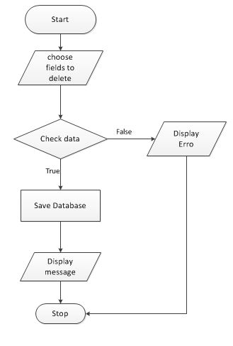

1. **Data flow diagram**
   1. **General Diagram**

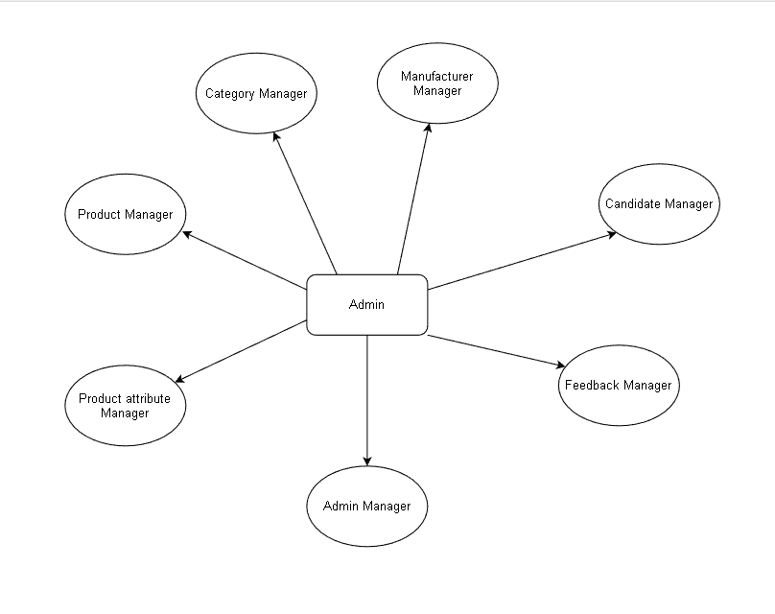

* 1. **Use case**

1. Login

Admin

Users

1. Change Profile

Customer

Candidate

1. Candidate Management

Candidate

Admin

1. Search

Users

1. Category Management

Category Manager

Admin

1. Product Management

Product Manager

Admin

1. Manufacturer Management

Manufacturer Manager

Admin

1. Product attribute Management

Product attribute

manager

Admin

1. Manager (Admin) Management

Admin Manager

Admin

1. Feedback Management

Admin

1. **Entity relationship diagram**
   1. **Entity relationship diagram**

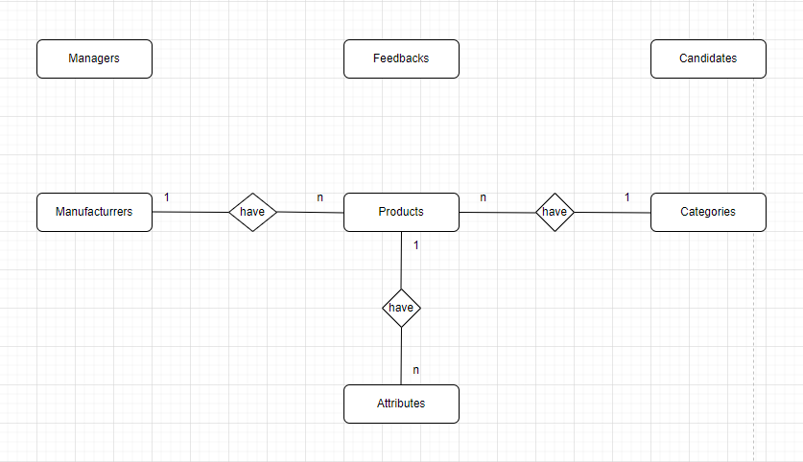

* 1. **Entity - Attributes**

**Managers**

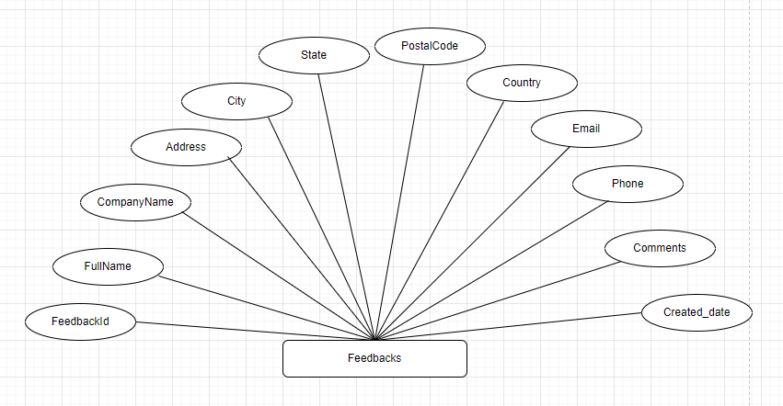

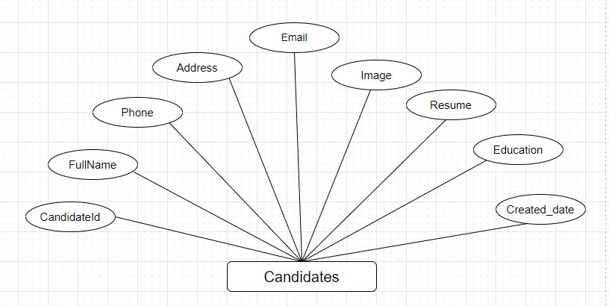

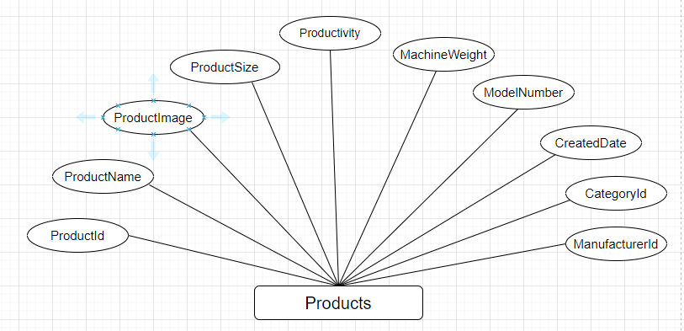

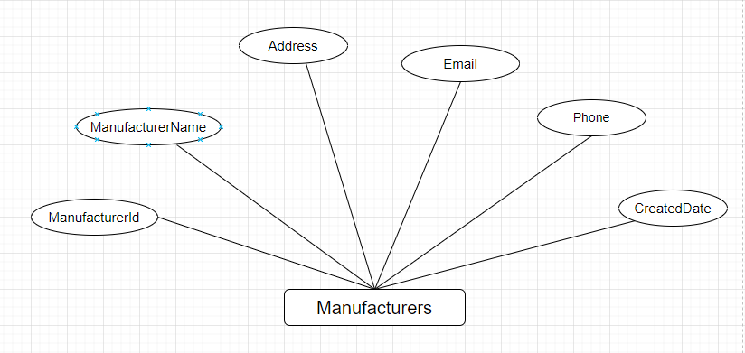

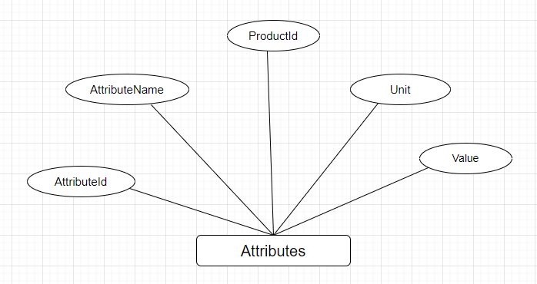

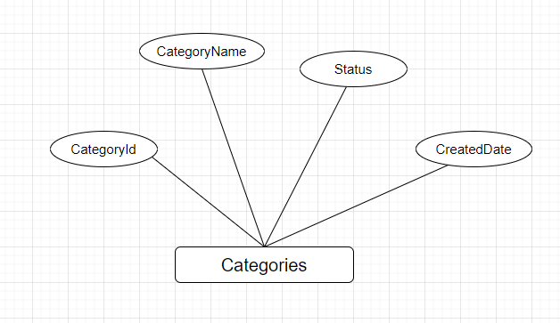

1. **Database Design/Structure**
   1. **Database relationship diagram**

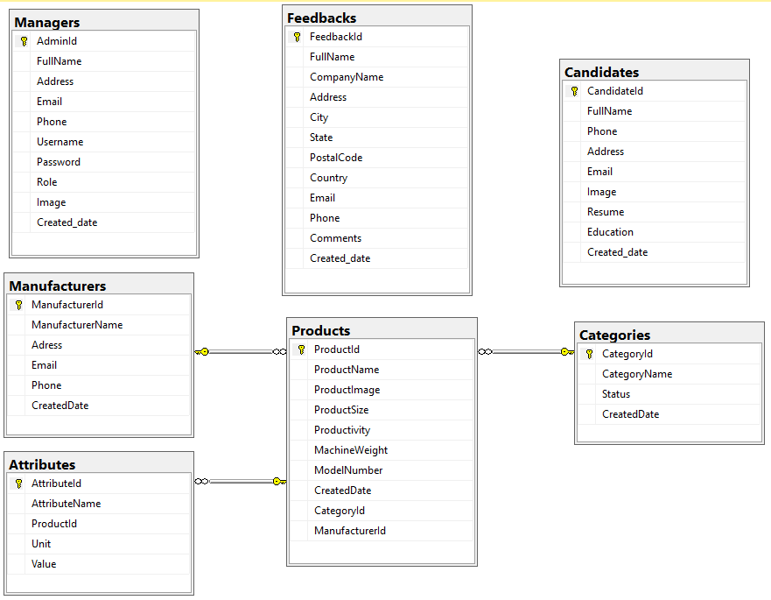

* 1. **Table Design**

|  |  |  |  |  |
| --- | --- | --- | --- | --- |
| **Table:Managers** | | | | |
| **Column** | **Data type** | **Allow Nulls** | **Key** | **Description** |
| AdminId | Guid | 🞎 | PK | ID of Managers |
| FullName | Nvarchar(200) | 🞎 |  | FullName of Managers |
| Address | Nvarchar(500) | 🗹 |  | Address of Managers |
| Email | Nvarchar(150) | 🞎 |  | Email of Managers |
| Phone | Nvarchar(50) | 🗹 |  | Phone of Managers |
| Username | Nvarchar(20) | 🞎 |  | Username of Managers |
| Password | Nvarchar(20) | 🞎 |  | Password of Managers |
| Role | int | 🗹 |  | Role of Managers |
| Image | Nvarchar(450) | 🗹 |  | Image of Managers |
| Created_date | DateTime | 🞎 |  | Date of Managers |

|  |  |  |  |  |
| --- | --- | --- | --- | --- |
| **Table:Candidates** | | | | |
| **Column** | **Data type** | **Allow Nulls** | **Key** | **Description** |
| CandidateId | int | 🞎 | PK | ID of Candidates |
| FullName | Nvarchar(200) | 🞎 |  | FullName of Candidates |
| Phone | Nvarchar(50) | 🞎 |  | Phone of Candidates |
| Address | Nvarchar(500) | 🗹 |  | Address of Candidates |
| Email | Nvarchar(200) | 🞎 |  | Email of Candidates |
| Image | Nvarchar(512) | 🗹 |  | Image of Candidates |
| Resume | Nvarchar(500) | 🞎 |  | Resume of Candidates |
| Education | Nvarchar(500) | 🞎 |  | Education of Candidates |
| Created_date | DateTime | 🗹 |  | CreatedDate of Candidates |

|  |  |  |  |  |
| --- | --- | --- | --- | --- |
| **Table:Feedbacks** | | | | |
| **Column** | **Data type** | **Allow Nulls** | **Key** | **Description** |
| FeedbackId | int | 🞎 | PK | ID of Feedbacks |
| FullName | Nvarchar(200) | 🞎 |  | FullName of Feedbacks |
| CompanyName | Nvarchar(150) | 🗹 |  | CompanyName of Feedbacks |
| Address | Nvarchar(500) | 🞎 |  | Address of Feedbacks |
| City | Nvarchar(100) | 🗹 |  | City of Feedbacks |
| State | Nvarchar(100) | 🗹 |  | State of Feedbacks |
| PostalCode | Nvarchar(300) | 🗹 |  | PostalCode of Feedbacks |
| Country | Nvarchar(150) | 🗹 |  | Country of Feedbacks |
| Email | Nvarchar(150) | 🞎 |  | Email of Feedbacks |
| Phone | Nvarchar(50) | 🗹 |  | Phone of Feedbacks |
| Comments | Nvarchar(1000) | 🞎 |  | Comments of Feedbacks |
| Created_date | DateTime | 🞎 |  | CreatedDate of Feedbacks |

|  |  |  |  |  |
| --- | --- | --- | --- | --- |
| **Table: Products** | | | | |
| **Column** | **Data Type** | **Allow Nulls** | **Key** | **Description** |
| ProductId | Nvarchar(450) | 🞎 | PK | ID of Products |
| ProductName | Nvarchar(500) | 🞎 |  | ProductName of Products |
| ProductImage | Nvarchar(512) | 🗹 |  | ProductImage of Products |
| ProductSize | Nvarchar(512) | 🗹 |  | ProductSize of Products |
| Productivity | Nvarchar(512) | 🗹 |  | Productivity of Products |
| MachineWeight | Nvarchar(512) | 🗹 |  | MachineWeight of Products |
| ModelNumber | Nvarchar(512) | 🗹 |  | ModelNumber of Products |
| CreatedDate | Varchar(20) | 🞎 |  | CreatedDate of Products |
| CategoryId | Varchar(20) | 🞎 | PK | CategoryId of Categories |
| ManufacturerId | varchar(50) | 🞎 | PK | ManufacturerId of Manufacturers |

|  |  |  |  |  |
| --- | --- | --- | --- | --- |
| **able: Manufacturers** | | | | |
| **Column** | **Data type** | **Allow Nulls** | **Key** | **Description** |
| ManufacturerId | int | 🞎 | PK | ID of Manufacturers |
| ManufacturerName | Nvarchar(400) | 🞎 |  | Name of Manufacturers |
| Adress | Nvarchar(500) | 🗹 |  | Address of Manufacturers |
| Email | Nvarchar(500) | 🗹 |  | Email of Manufacturers |
| Phone | Nvarchar(500) | 🗹 |  | Phone of Manufacturers |
| CreatedDate | DateTime | 🞎 |  | CreatedDate of Manufacturers |

|  |  |  |  |  |
| --- | --- | --- | --- | --- |
| **Table:Categories** | | | | |
| **Column** | **Data type** | **Allow Nulls** | **Key** | **Description** |
| CategoryId | Int | 🞎 | PK | ID of Categories |
| CategoryName | Nvarchar(400) | 🞎 |  | Name of Categories |
| Status | int | 🞎 |  | Status of Categories |
| CreatedDate | DateTime | 🞎 |  | CreatedDate of Categories |

|  |  |  |  |  |
| --- | --- | --- | --- | --- |
| **Table: Attributes** | | | | |
| **Column** | **Data type** | **Allow Nulls** | **Key** | **Description** |
| AttributeId | int | 🞎 | PK | ID of Attributes |
| AttributeName | Nvarchar(400) | 🞎 |  | Name of Attributes |
| ProductId | Nvarchar(450) | 🗹 | PK | ProductId of Products |
| Unit | Nvarchar(500) | 🗹 |  | Unit of Attributes |
| Value | Nvarchar(500) | 🞎 |  | Value of Attributes |

1. **Some typical interface**

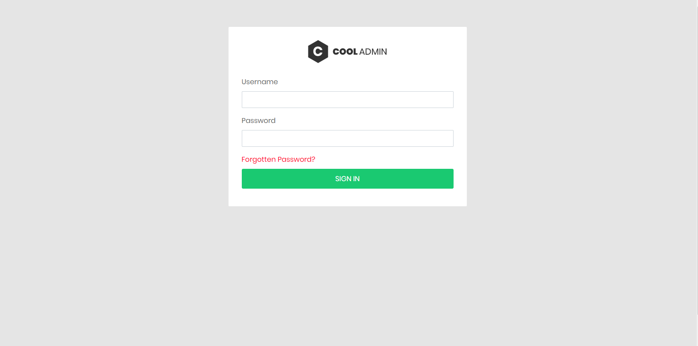

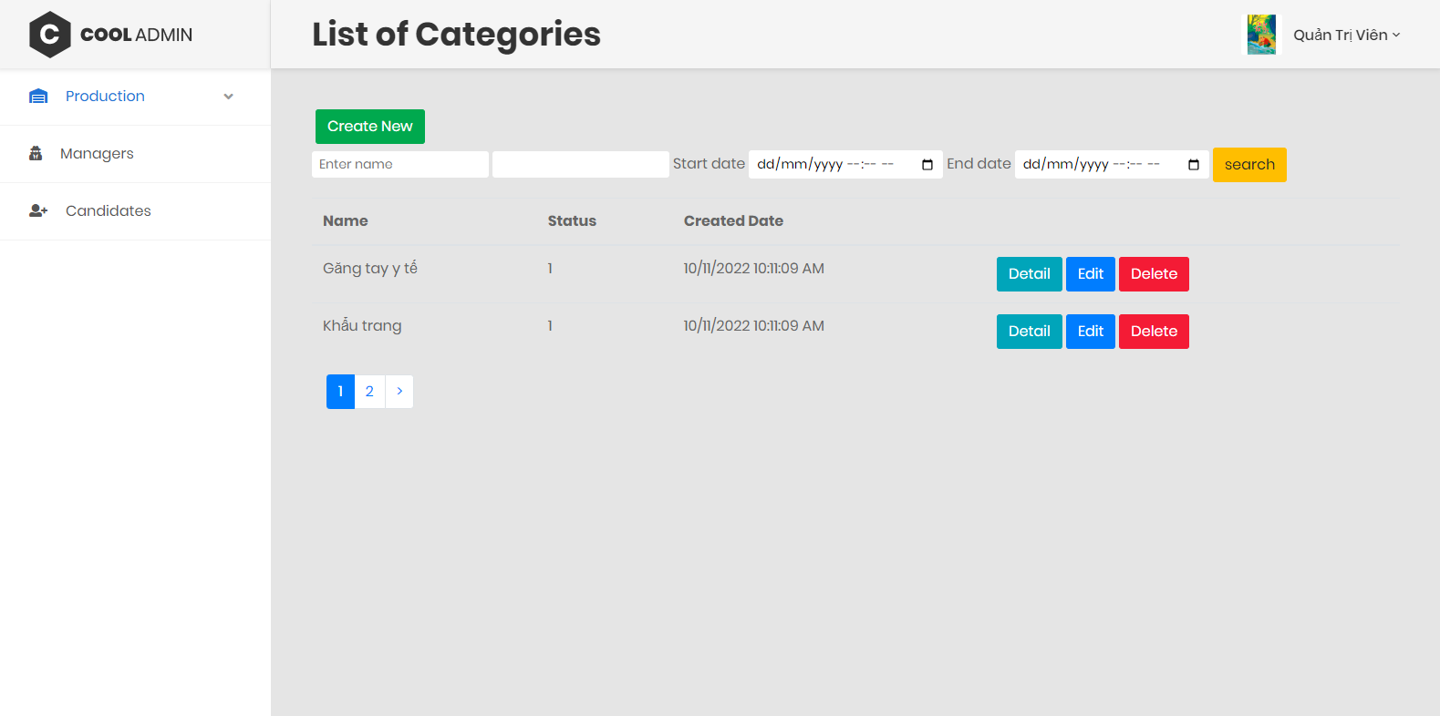

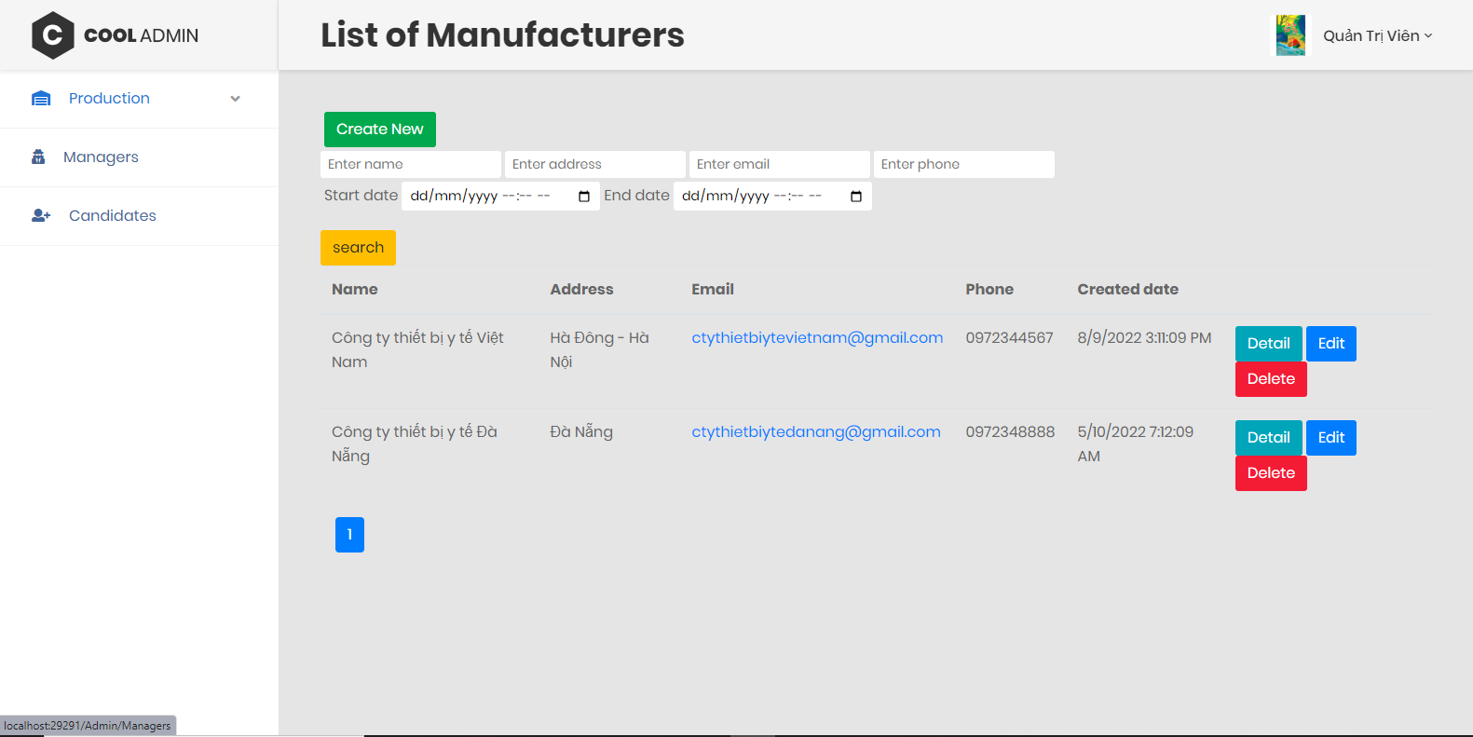

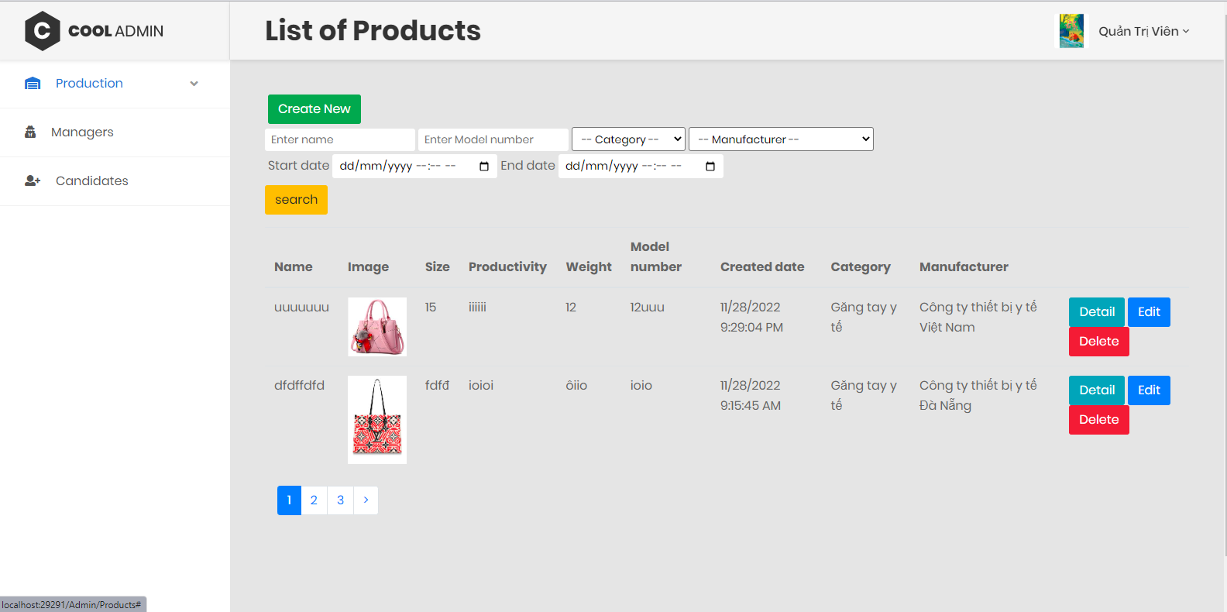

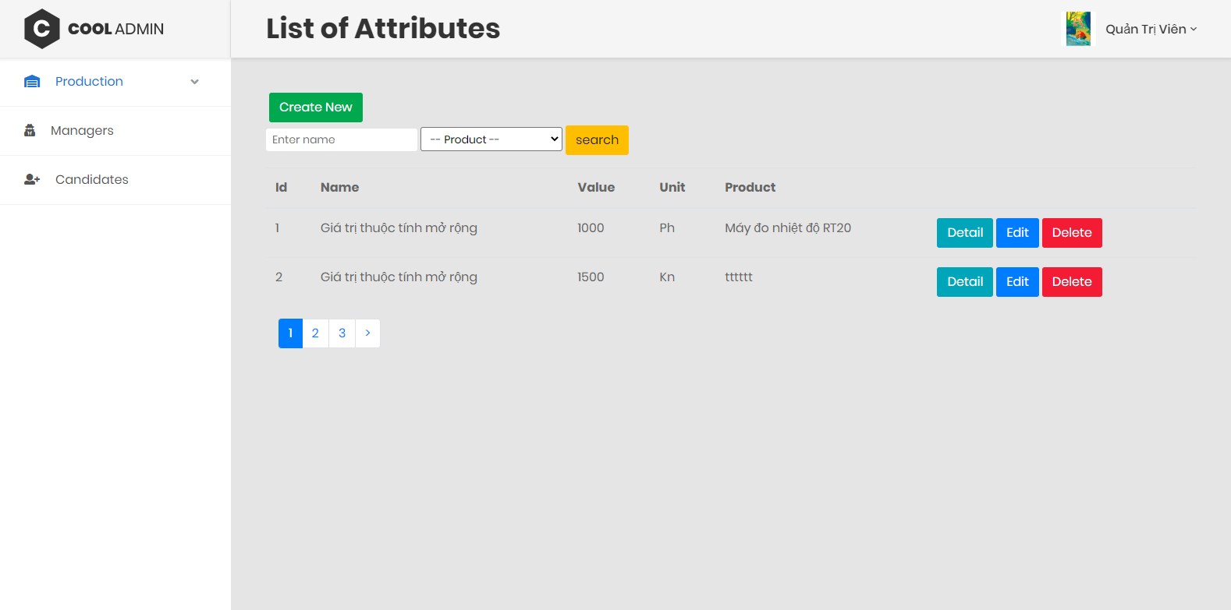

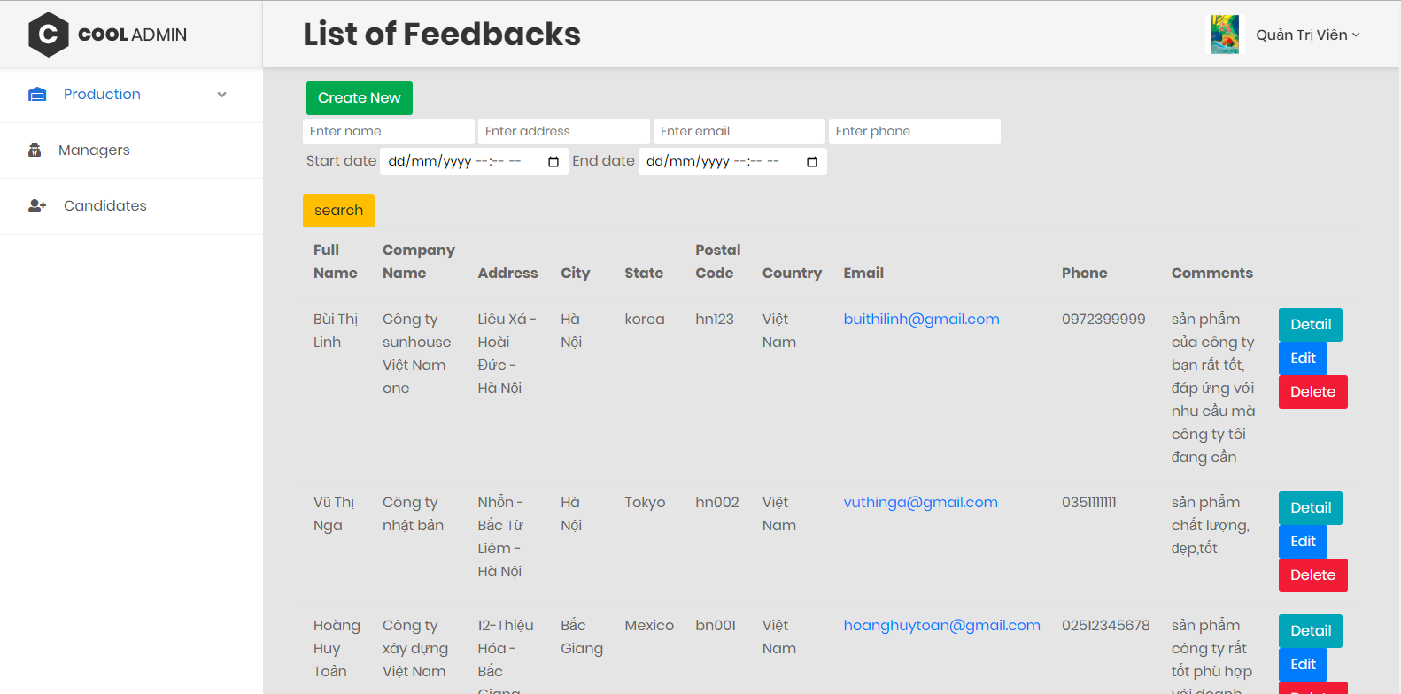

1. **Task Sheet**

|  |  |  |  |  |  |  |
| --- | --- | --- | --- | --- | --- | --- |
| E**Project Ref. No: 1** | | **EProject Title: XYZ Pharmaceuticals** | **Date of Preparation of Activity Plan** | | | |
| **Sr. No.** | **Task** | | **Actual Start Date** | **Actual Days** | **Team Member Names** | **Status** |
| 1 | Problem definition | |  | 1 | Pham Dinh Bach | complete |
| 2 | API | |  | 10 | Pham Dinh Bach | complete |
| 3 | Admin functions | | Pham Dinh Bach | complete |
| 4 | Authentication | |  | 9 | Do Van Minh | complete |
| 5 | Admin Login | | Do Van Minh | complete |
| 6 | Feedback functions | |  | 2 | Do Van Minh | complete |
| 7 | Candidate functions | |  | 2 | Pham Dinh Bach | complete |
| 8 | Customer functions | |  | 3 | Do Van Minh | complete |
| 9 | Send Email for Candidate | |  |  | Pham Dinh Bach | Not complete |

1. **Check list of validation**

|  |  |
| --- | --- |
| Option | Validate |
| Can a new user who get registered, enter the application after logging in ? | Yes |
| Do all the option present in the application display the correct result | Yes |
| Does the application’s functionality resolve the user problem and satisfy their needs ? | Yes |
| Has the hardware and software been correctly chosen ? | Yes |

1. **Submission checklist**

|  |  |  |  |  |
| --- | --- | --- | --- | --- |
| Sr.No | Particular | Yes | No | Comments |
| 1 | Are the users able to login to application after validations is performed on the on the user name and password ? | Yes |  |  |
| 2 | Are the user able to modify their detail after getting registered | Yes |  |  |
| 3 | Are all the screen contents devoid spelling mistakes | Yes |  |  |
| 4 | Is the application user-friendly | Yes |  |  |

**THE END**